THE PRINCIPLES OF DESIGN

BALANCE – A principle of design that refers to the equalization of elements. There are three
kinds of balance: symmetrical, asymmetrical, and radial.

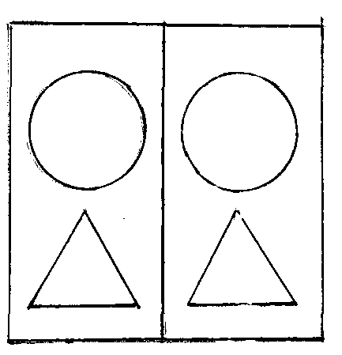 | 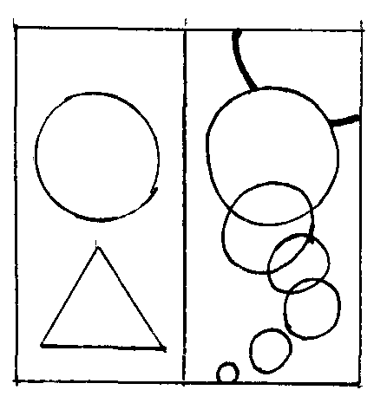 | 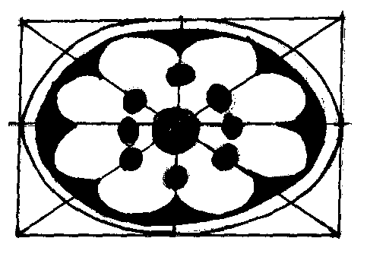
symmetrical | asymmetrical | radial

UNITY – A principle of design that relates to the sense of one-ness or wholeness in a work of
art. There is something similar throughout the entire design.
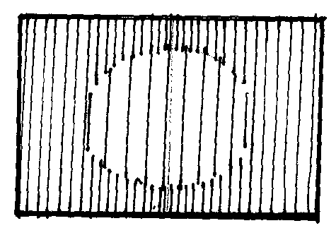

MOVEMENT – A principle of art referring to a way of combining art elements to produce a look and feel of action, or
to cause the viewer’s eye to travel over the artwork in a certain way.

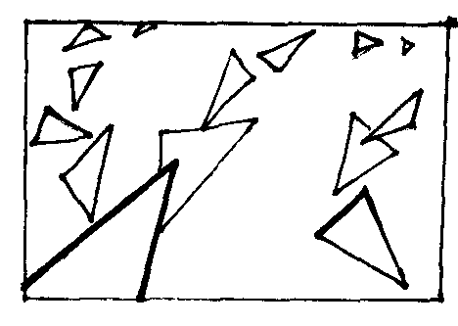

PATTERN – A principle of design referring to the combinations of lines, colors, and shapes repeated in a series.
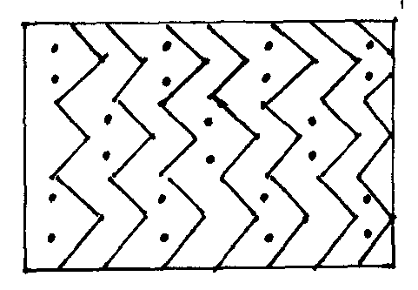

RHYTHM – A principle of design where movement and repetition occur together. Usually
the same or similar objects repeat or change in their placement or size as they move.
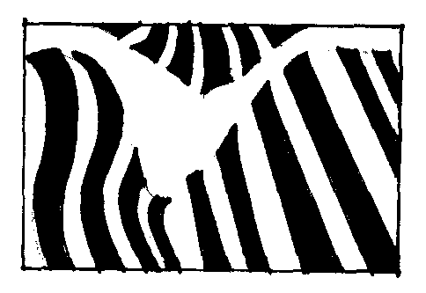

EMPHASIS - A principle of design that uses size, contrasting colors, or placement to draw
attention to a certain object in a work of art.

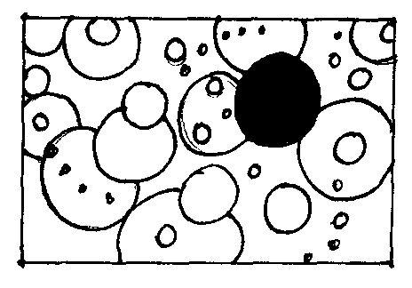

CONTRAST – A principle of design that refers to differences in elements in a work of art. Two
very different elements are combined in the same work (i.e. dark vs. light value, bright vs. dull color,
geometric vs. organic shapes) etc.
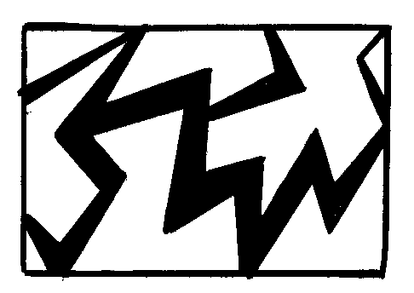

VARIATION – A principle of design which refers to the changing or differing characteristics of elements in a
work of art.
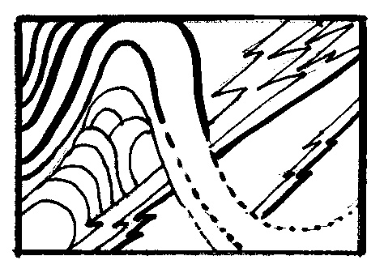 | Line was the focus in this drawing. Many variations of lines were used to create this design.

