THE ELEMENTS OF ART

LINE – An element of art which refers to the continuous mark made on a surface by a moving point (i.e. 2-dimensional
pencil marks on paper or 3-dimensional wire lines). Line is often an outline, contour, or silhouette which is
implied. Lines come in many variations: curved, straight, broken, thick, thin, zigzag, implied, etc.
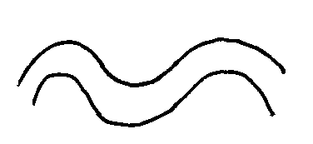 |  |  |  | _ _ _ _  . . . . . . |  | 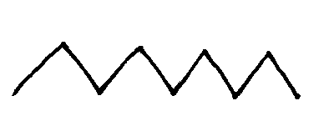 | implied

SHAPE – An element described as 2-dimensional enclosed space. Shapes can be geometric
(square, circle, triangle, etc.) or organic (irregular).

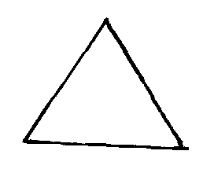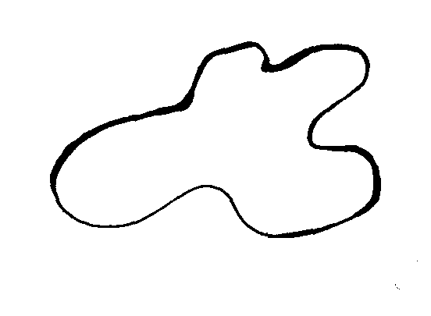
geometric organic

SPACE – An element that indicates either positive or negative areas, or ways to show
depth in space using foreground, middle ground and background
background
 |  | 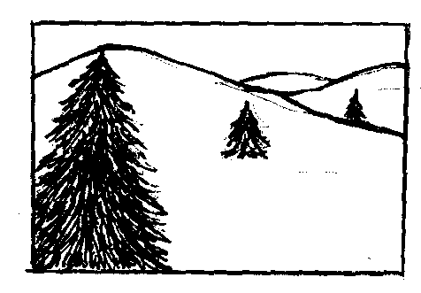
positive space | negative space

FORM – An element of art that is described as 3-dimensional (having height, width and depth) and which encloses
volume (i.e. cylinders, cubes, spheres, etc.)
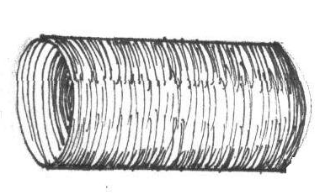 | 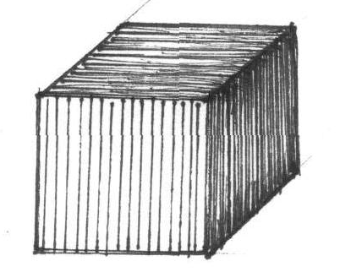 | 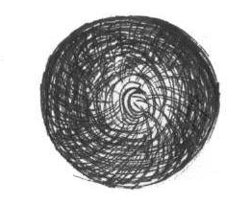

TEXTURE – An element that refers to the surface quality (rough, smooth, etc.) of an object or artwork. Texture can be
actual or implied. Drawings and paintings describe implied textures. Actual textures are those you can
actually feel.

 |  | 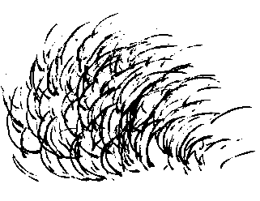 | 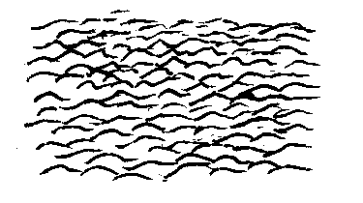

COLOR – An element that identifies hues such as red, yellow, violet, etc. Color groups: Primary: red, yellow, blue;
Secondary: orange, purple, green; Analogous: 3-5 colors immediately next to one another on the color wheel
that share a common hue (i.e. red, red-violet, violet, blue-violet share the color red). Complementary: (2)
colors directly across from one another on the color wheel (i.e. red and green). Monochromatic: Different
values of one color (tints and shades).

VALUE – An element that refers to the lightness or darkness of a color. A color’s value is lightened by the addition of
white (tint) and darkened by the addition of black (shade).

